THE REBUILD:
Brad Keller's Conversion from Starter to Elite Reliever,
and What It Was Worth
A Statistical and Market-Value Analysis of the 2025 Season
September 2026
Kansas City Royals → Chicago White Sox / Boston Red Sox → Chicago Cubs → Philadelphia Phillies

Executive Summary
Brad Keller entered 2025 as one of baseball's lowest-profile reclamation projects: a former Kansas City Royals mid-rotation starter whose career had been derailed by injury and ineffectiveness in 2023 and 2024. Unable to land a guaranteed major-league contract, he signed a minor-league deal with a spring-training invite from the Chicago Cubs on January 29, 2025. By October, he had become one of the Cubs' most trusted late-inning arms, and by December he had signed a two-year, $22 million contract with the Philadelphia Phillies.
This report traces that transformation in three parts: (1) the on-field and Statcast-level changes that accompanied Keller's move from starter to high-leverage reliever — velocity, pitch mix, and role usage; (2) the resulting performance outcomes across traditional and advanced metrics; and (3) how those changes translated into free-agent market value, comparing pre-season and pre-free-agency projections to the contract he actually signed.
5.44  2024 ERA (SP/RP mix)  41.1 IP — CWS/BOS | 2.07  2025 ERA (Reliever)  69.2 IP — Cubs | +3.5–4 mph  Velocity Gain  4-seam fastball | $22M / 2 yrs  Contract Signed  Phillies, Dec. 2025
Figure 1. Headline before/after metrics, 2024 season to 2025 free agency.

1. Before the Breakout: Career Context and Market Value Entering 2025
Keller debuted with the Royals in 2018 and spent four full seasons (2018–2021) as a rotation piece, posting a 3.50 ERA across 360.1 innings from 2018–2020 before his performance and health declined. 2022 and 2023 were transitional and injury-shortened; a shoulder impingement and a subsequent surgery to address thoracic outlet syndrome limited him to a combined 27 appearances across 2023–2024, during which he produced roughly –0.6 combined WAR. A split 2024 season with the Chicago White Sox and Boston Red Sox produced an 0-4 record and a 5.44 ERA over just 41.1 innings.

1.1 Career Year-by-Year Performance
Season | Team(s) | Role | G (GS) | IP | ERA | K
2018 | Kansas City | Starter | 36 (28) | 140.1 | 3.08 | 91
2019 | Kansas City | Starter | 31 (31) | 165.1 | 4.19 | 122
2020 | Kansas City | Starter | 9 (9) | 54.2 | 2.47 | 35
2021 | Kansas City | Starter | 26 (26) | 133.2 | 5.39 | 120
2022 | Kansas City | Starter/RP | 35 (22) | 139.2 | 5.09 | 102
2023 | Kansas City | Starter | 11 (9) | Limited (IL, shoulder) | — | —
2024 | CWS / Boston | Starter/RP | — | 41.1 | 5.44 | —
2025 | Chicago Cubs | Reliever | 68 (1) | 69.2 | 2.07 | 75
Figure 2. Career progression, Kansas City Royals (2018–2023) through the 2025 Cubs breakout season. Career totals through 2025: 234 games, 4.14 ERA, 5 saves (3 in 2025).
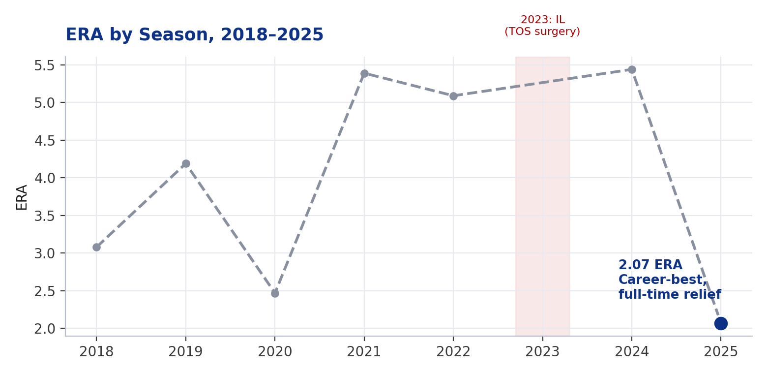
Figure 3. ERA by season. The 2023 gap reflects a season cut short by a shoulder impingement and subsequent thoracic outlet syndrome (TOS) surgery.
That injury and performance history depressed Keller's market to almost nothing entering 2025. Rather than a guaranteed major-league deal, he accepted a minor-league contract with a spring-training invite — effectively a no-risk, upside-only flier for the Cubs, and a signal that the open market placed close to replacement-level value on him at that point in his career.

1.2 A Closer Look at 2024: White Sox and Red Sox
The 2024 season — the year immediately preceding his breakout — was itself a story of two brief, unsuccessful major-league stints sandwiched around minor-league detours. Keller signed a minor-league deal with the White Sox in March 2024, opened the year at Triple-A Charlotte, and was called up April 28. He was briefly inserted into Chicago's rotation in mid-May before struggling and being designated for assignment on May 20. After electing free agency, he signed with the Red Sox on May 26 and worked exclusively in relief, but was again unable to find consistent success at the major-league level before finishing the year with a second Triple-A stint at Worcester.
Stop | Dates | Role | G (GS) | IP | ERA | Result
White Sox (MLB) | Apr 28 – May 20 | Rotation (mid-May) | 5 (2) | 16.2 | 4.86 | Designated for assignment
Red Sox (MLB) | May 27 – Jun 23 stint* | Relief only | 9 (0) | 16.2 | 5.40 | 1 SV (Jun 13 vs. PHI)
Triple-A (both orgs) | Full season | Mixed | 16 (13) | 68.2 | 3.28 | 4-4 record
2024 MLB Total | Full season | Mixed | — | 41.1 | 5.44 | 0-4, 1 SV
Figure 4. 2024 season detail, Chicago White Sox and Boston Red Sox organizations. *Red Sox MLB line reflects a reported early-stint sample (9 G); Keller had at least one additional recall later in the season, folded into the 41.1-inning MLB total above. Sources: MLB.com, MLB Trade Rumors, Boston Globe.
The throughline from 2022–2024 is a pitcher stuck between roles: not effective enough as a starter to hold a rotation spot, and not yet re-optimized for relief work. That changed the moment Chicago's coaching staff got a full off-season with him.

2. The Transition: Role, Velocity, and Pitch Arsenal Changes
Keller's contract was selected on March 27, 2025, adding him to the Cubs' Opening Day roster as a reliever — a permanent departure from the starter track he had followed his entire career. He went on to lead the Cubs in appearances (68, with only a single start) and was deployed increasingly in high-leverage situations as the season progressed, ultimately closing out several September and October games and recording a four-out save in Game 3 of the NLDS against Milwaukee on October 8, 2025.

2.1 Velocity
The move to one-inning relief outings produced an immediate and substantial velocity spike. Per Baseball Savant, Keller's average four-seam fastball jumped from 93.7 mph in 2024 to 97.1 mph in 2025 — a gain of roughly 3.4–4 mph — with in-game readings regularly sitting in the 95–99 mph range and touching as high as 99.0 mph in key strikeout moments. Statcast's percentile rankings placed that 97.1 mph average in the 88th percentile leaguewide.
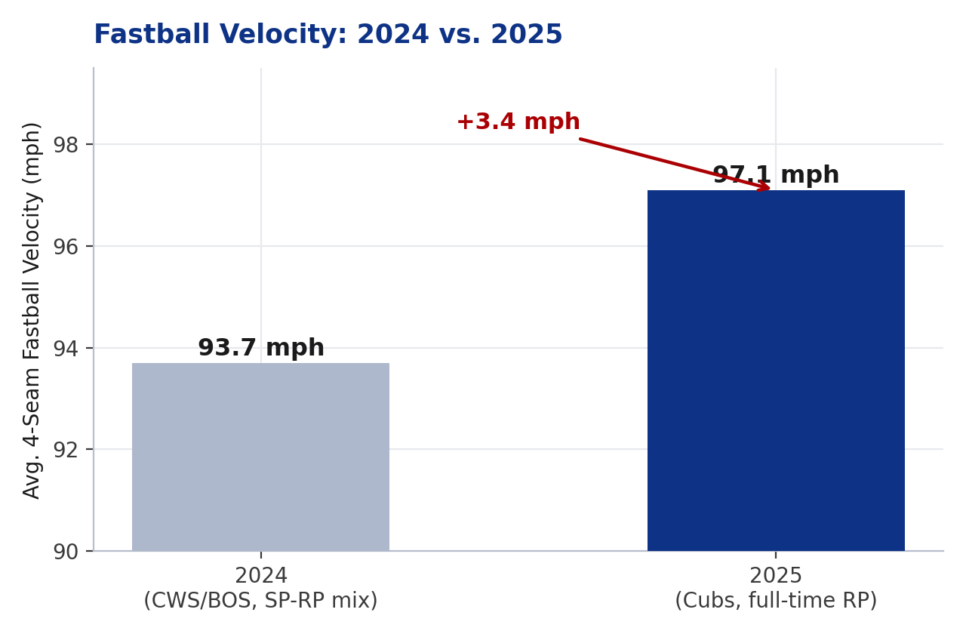
Figure 5. Average four-seam fastball velocity, 2024 (starter/swingman) vs. 2025 (full-time relief). Source: Baseball Savant.

2.2 Pitch Usage and New Arsenal Pieces
Rather than simplifying to a two-pitch relief mix, Keller kept a full five-pitch arsenal, leaning on the added velocity to make his existing pitches play up and increasing his fastball's rate of pitches thrown in the strike zone from roughly 53% to 60%. In his own description of the change, Keller pointed to a heavier dose of sinkers and a splitter-like changeup, on top of the hard slider he had always thrown — and, new to his repertoire, a sweeper that quickly became one of his most effective weapons against right-handed hitters.
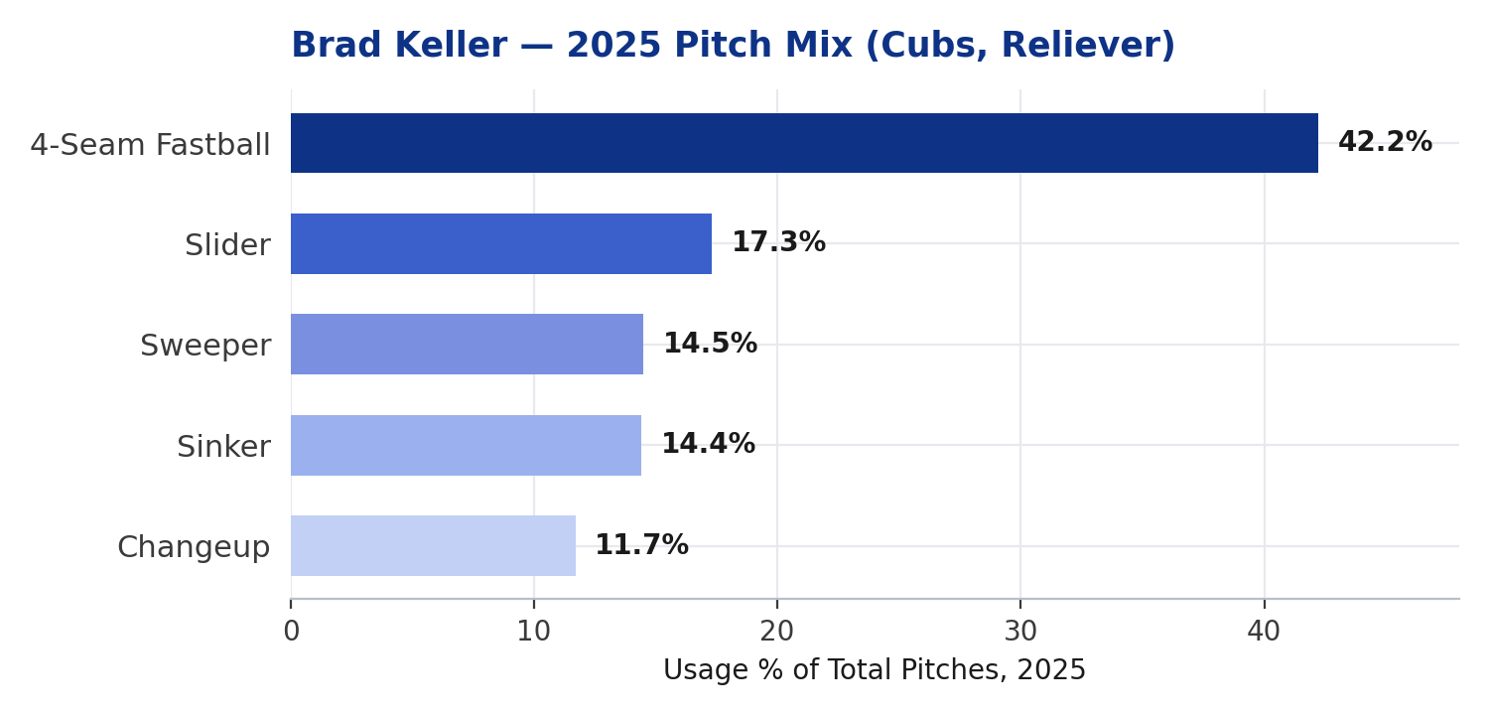
Figure 6. 2025 pitch mix by usage share. Source: Baseball Savant Statcast pitch arsenal data.
Pitch | 2025 Usage % | Avg. Velocity | Notable Profile
4-Seam Fastball | 42.2% | 97.1 mph | Cutter-shaped movement; zone rate rose from ~53% to 60%
Slider | 17.3% | 88.0 mph | Primary putaway pitch vs. RHB
Sweeper | 14.5% | 86.3 mph (avg.) | ~2,720 RPM; opponents hit .067 against it in 2025
Sinker | 14.4% | mid-90s | Tunnels off four-seam shape; heavier usage per Keller
Changeup | 11.7% | ~92–93 mph | “Split-change” feel; keeps LHB off balance
Figure 7. 2025 pitch-by-pitch usage and velocity profile as a Cubs reliever. Source: Baseball Savant / Statcast.

2.3 Pitch Mix: Starter Years vs. 2025 Relief Role
Comparing his relief-era mix to his rotation years shows the shift is about more than raw stuff — the shape of the arsenal itself changed. As a starter, Keller leaned heavily on his slider and sinker to generate ground balls deep into games; as a reliever, the fastball became the clear primary weapon, the once-nonexistent sweeper immediately became a top-three pitch, and the slider/sinker usage receded in relative terms even as both gained velocity.
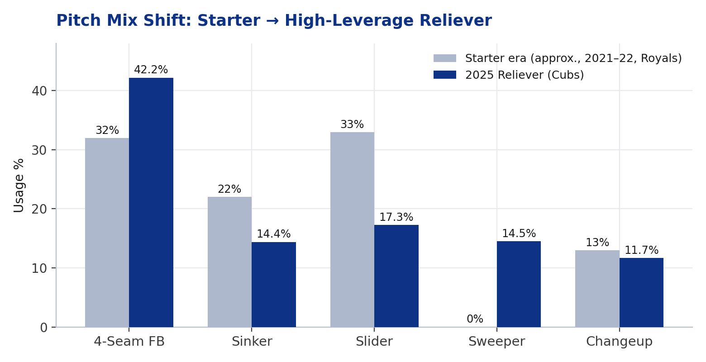
Figure 8. Approximate starter-era mix (2021–22, Kansas City) vs. 2025 reliever mix (Cubs). Starter-era figures are reconstructed from public year-by-year usage reporting rather than a single Savant export and should be read as directional, not exact; the 2025 bars are the precise Statcast figures from Figure 7.

2.4 Pitch Movement Profile (Statcast Ball-Tracking Data)
Statcast's ball-tracking data — captured by Hawk-Eye optical tracking, which replaced the original TrackMan/Doppler radar system leaguewide starting in 2020 — shows how Keller's four active breaking and off-speed pitches separate from one another and from his fastball. The sweeper and slider break to his glove side with heavy vertical drop, while the changeup mirrors the fastball's arm-side action at a reduced velocity — the kind of shared spin direction that makes pitches harder for hitters to distinguish out of the hand.
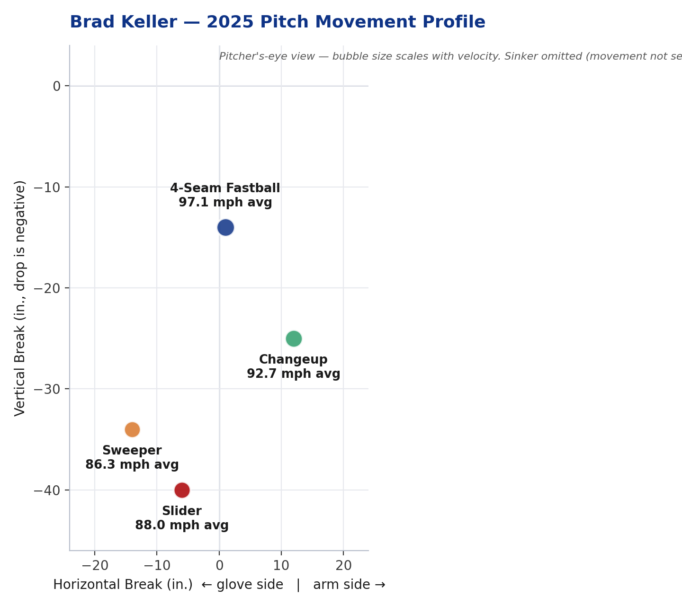
Figure 9. 2025 total pitch movement (horizontal break vs. vertical drop, pitcher's-eye view), bubble size scaled to velocity. Source: Baseball Savant pitch-tracking data.
The net effect was a pitcher who, as a starter, worked backwards off an average mid-90s fastball with modest zone rates and, as a reliever, could attack the zone with a harder fastball, tunnel a plus slider and a new sweeper off it, and hold both sides of the plate: right-handed hitters slashed just .148 with a .466 OPS against him over 153 plate appearances in 2025, while left-handed hitters managed only a .223/.293/.277 line with a 26% strikeout rate over 123 plate appearances.

3. Performance Outcomes: 2025 Season in Full
2.07  ERA  68 G, 1 GS | 0.96  WHIP | 75  K  9.7 K/9 | 69.2  IP  Regular season | 4-2  Record  3 SV | 1.4  bWAR  Career-best
Figure 10. 2025 regular-season statistical line, Chicago Cubs.
Keller's regular-season performance carried into October: across five postseason appearances he posted a 1.59 ERA, including the four-out save in the Cubs' NLDS Game 3 win over Milwaukee that forced a Game 4. The consistency of his performance across the highest-leverage stretch of the season — not just a hot two-month sample — is what ultimately drove his free-agent stock.

4. Market Value: Projected vs. Actual

4.1 Entering the 2025 Season
As detailed in Section 1, Keller's market value entering 2025 was minimal: a non-guaranteed minor-league contract with the Cubs was the best offer available to a pitcher who had accumulated roughly –0.6 WAR across his two prior injury-shortened seasons.

4.2 Pre-Signing Free-Agent Projections (Late 2025)
Keller's 2025 breakout completely reset that valuation. Entering the 2025–26 free-agent class, MLB Trade Rumors projected a three-year, $36 million contract, with several analysts framing him as a candidate for a reliever-to-starter conversion in the mold of Michael King, Seth Lugo, and Clay Holmes — pitchers who successfully leveraged a relief breakout into a starting role and a bigger multi-year deal. ESPN's Kiley McDaniel listed Keller among free agents to “invest in,” citing the velocity gain, the improved zone rate, and pitch-shape traits (a cutter-shaped fastball favored by pitch-design-oriented front offices) that made him attractive as a potential 150-inning starter. At least one club, the Detroit Tigers, was reported to have specific interest in Keller as a starter.

4.3 The Actual Contract
On December 17, 2025, Keller agreed to a two-year, $22 million contract with the Philadelphia Phillies, finalized the following day after he passed his physical. The deal — identical in structure to the two-year, $22 million contract free-agent reliever Luke Weaver signed with the New York Mets the same day — was reported as a pure relief contract, with Keller ticketed to set up for closer Jhoan Durán rather than compete for a rotation spot. That places the deal below the $36 million, three-year ceiling some projections floated for a starter-conversion bet, indicating the market ultimately valued Keller as a premium high-leverage reliever rather than as a rotation gamble.
Stage | Valuation | Basis
Entering 2025 | Minor-league deal (non-guaranteed) | –0.6 combined WAR, 2023–24; injury history
Pre-free-agency projection | 3 yrs / $36M (MLBTR) | 2025 breakout; viewed as starter-conversion candidate
Actual signing (Dec. 2025) | 2 yrs / $22M — Philadelphia Phillies | Pure relief role; setup for closer Jhoan Durán
Figure 11. Market value at three points in Keller's 2025–26 arc.
The Cubs, for their part, stayed engaged with Keller's camp (Excel Sports Management) throughout the process but let his market move past their “financial comfort zone,” opting instead to address the bullpen with a two-year, $14.5 million deal for Phil Maton and one-year deals for Caleb Thielbar and Hoby Milner.

5. Conclusion
Brad Keller's 2025 season is a compact case study in how a single mechanical and role change — shifting from multi-inning starting outings to one-inning relief stints — can reshape a pitcher's stuff, performance, and market value almost overnight. The velocity gain unlocked a two-pitch bat-missing combination (slider/sweeper) that simply wasn't playable at his starter-era fastball velocity, and the performance that followed (2.07 ERA, 0.96 WHIP, 1.4 bWAR, a sub-2.00 postseason ERA) took him from a non-guaranteed minor-league contract to a $22 million guarantee in under twelve months. That said, the final number — a two-year, pure-relief deal — also shows the limits of the starter-conversion premium some forecasters expected: the market rewarded Keller as an elite reliever, not as a starter prospect, suggesting that teams valued the demonstrated 2025 role over the hypothetical of stretching him back out.

Sources: Baseball Savant / Statcast, MLB.com, ESPN, MLB Trade Rumors, CBS Sports, Chicago Sun-Times, Bleacher Nation, Yahoo Sports, RotoWire, and team-reported transaction details, compiled September 2026.

